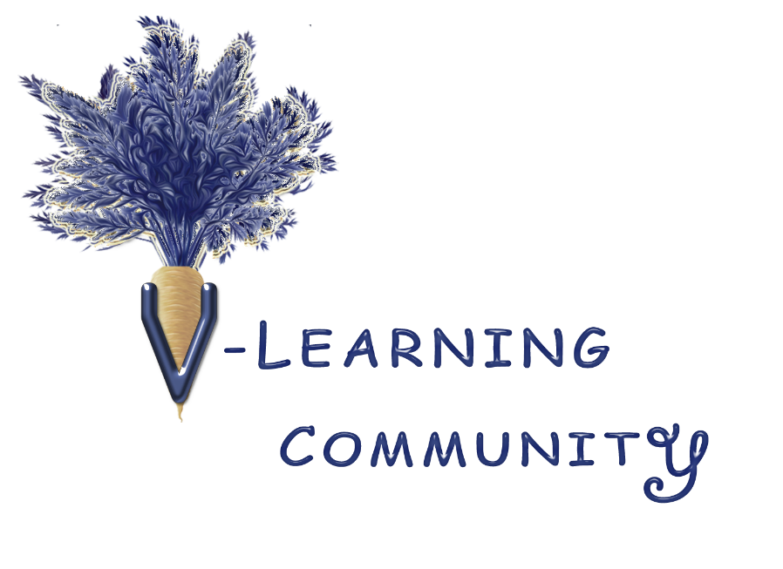
Questions in a Bowl
Instructions: print and cut into strips. Then fold in halves. Put in a bowl and read them out to spark a conversation. Please see disclaimer for further information.

What do you like most about being vegan or vegetarian (or thinking about it)?

What have been your hurdles to becoming vegan? If you've overcome them, how?

Why are you vegan? Or thinking of becoming vegetarian/vegan?

What was your journey to becoming vegan?

What speakers or organizations would you like to see?

Favorite vegan dish that you create or buy?

As a new vegan, I need…

I'm thinking of becoming vegetarian or vegan but ____ is holding be back.

Have you discovered a new food product?

What is your favorite vegan organization and why?

Who’s your favorite vegan advocate and why?
How do you answer this question: don't you miss having meat, cheese, eggs, etc.?

How do you respond to this comment: it's too hard? I don't think I could do it.

How do you answer this question: what do you do around the holidays?

What’s a common question you get as a vegan, and how do you answer it?

How do you answer this comment: fishing and hunting is part of my tradition? We've always done it.

I wish I knew more about...so I could...

What’s your favorite vegan cheese alternative?
What’s your favorite vegan seafood alternative?

What’s your favorite vegan burger, bacon or beef alternative?
What’s your favorite vegan chicken or turkey alternative?
What’s your favorite vegan ice cream alternative?

What’s your favorite vegan (and gluten free) bread alternative?

What’s your favorite vegan egg alternative for baking or scrambled?

What’s your favorite vegan sweetener alternative?

What has lasted the test of time? Is there something you liked as a kid that still brings you joy? Lastly, is it somehow connected to your vegetarian or vegan journey?

