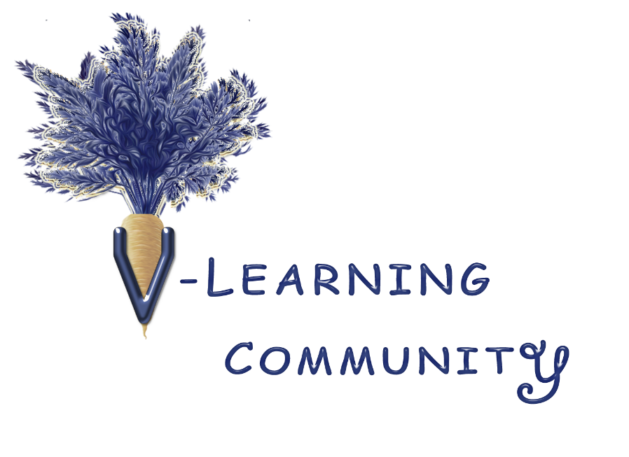

Sample Training Invitation

Learning Event

Hello,

Please join us for a virtual brunch on xx/xx/xx from xx to xx.
We’ll spend our visit learning about (may want to insert topics from Continuing Education page).
​We’ll watch film clips on these topics and explore our insights and perceptions.
Looking forward to seeing you!

Community Event
Hello,

Please join us for a virtual dinner on xx/xx/xx from xx to xx.

Let's get together for some open community time to talk about documentaries we’ve seen, books, websites, upcoming events, our experiences and questions, or whatever else interests us.

If you like, please bring a favorite kitchen tool, ingredient, product...your dog, or anything from home that you'd like to share.

Looking forward to visiting with you!

This is for information purposes only and does not constitute a recommendation, offer, or solicitation of any kind.
Please visit www.vlearningcommunity.org for full disclaimer, learning materials, and virtual events.

